Ερώτημα 1

Κώδικας:
LIBRARY ieee ;
USE ieee.std_logic_1164.all;

ENTITY mux2to1 IS PORT (
a, b, s: IN bit;
c: OUT bit);
END mux2to1 ;

ARCHITECTURE dataflow OF mux2to1 IS
BEGIN
c <= a WHEN s='1' ELSE b;
END dataflow;
Wave

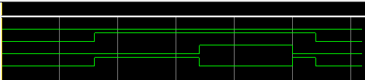
Ερώτημα 2

Κώδικας:

LIBRARY ieee ;
USE ieee.std_logic_1164.all;

ENTITY mux2to1 IS PORT (
a, b, s: IN bit;
c: OUT bit);
END mux2to1 ;

ARCHITECTURE dataflow OF mux2to1 IS
BEGIN
c <= a WHEN s='1' ELSE b;
END dataflow;

Κώδικας TestBench:

entity test_mux is
end test_mux;

architecture test_b of test_mux is
signal A1, B1, S1, C1: bit;
component mux2to1 port (a, b, s: in bit; c: out bit);
end component;

begin
M1: mux2to1 PORT MAP (a=>A1, b=>B1, s=>s1, c=>c1);
process
begin
A1 <= '1'; B1 <= '0'; S1 <= '1'; wait for 20 ps;
A1 <= '1'; B1 <= '0'; S1 <= '0'; wait for 20 ps;
end process;
end test_b;

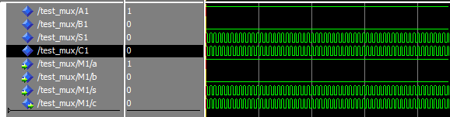
Wave
Ερώτημα 3

Κώδικας:
LIBRARY ieee ;
USE ieee.std_logic_1164.all;

ENTITY mux2to1 IS PORT (
a, b: in std_logic_vector(2 downto 0);
s: in std_logic;
d: out std_logic_vector(2 downto 0));
END mux2to1 ;

ARCHITECTURE dataflow OF mux2to1 IS
BEGIN
d <= a WHEN s='1' ELSE b;
END dataflow;

Wave

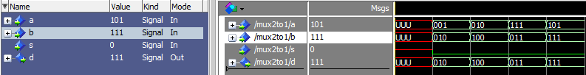

Πίνακας:

s | a | b | d
0 | 001 | 010 | 001
0 | 010 | 100 | 010
0 | 111 | 011 | 111
0 | 101 | 111 | 101
1 | 010 | 001 | 001
1 | 000 | 101 | 101
1 | 101 | 010 | 010
1 | 111 | 101 | 101

Ερώτημα 4

Κώδικας:

Wave
entity mux_4to1 is port (
a: in std_logic_vector(4 downto 1);
s: in std_logic_vector(2 downto 1);
d: out std_logic);
end mux_4to1;

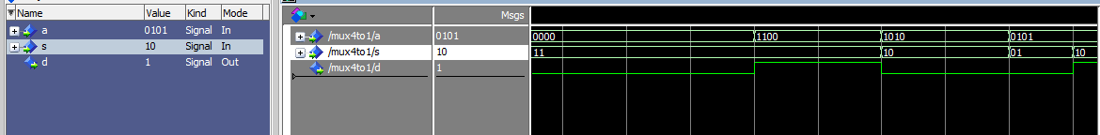
Πίνακας:

a | s | d
0000 | 00 | 0
0101 | 01 | 0
1010 | 10 | 0
1100 | 11 | 0
Ερώτημα 5

Κώδικας:
LIBRARY ieee ;
USE ieee.std_logic_1164.all;

entity dec2to4 is
port (
a: in std_logic_vector(2 downto 1);
d: out std_logic_vector(4 downto 1));
end dec2to4;

ARCHITECTURE dataflow OF dec2to4 IS
BEGIN
d(1) <= not a(1) and not a(2);
d(2) <= not a(1) and a(2);
d(3) <= a(1) and not a(2);
d(4) <= a(1) and a(2);
END dataflow;

Wave

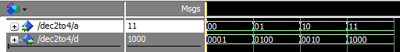
Πίνακας:

a | d
00 | 0001
01 | 0100
10 | 0010
11 | 1000

Ερώτημα 6

Κώδικας:

LIBRARY ieee ;
USE ieee.std_logic_1164.all;

entity dec_2to4 is
port (
a: in std_logic_vector(2 downto 1);
en: in std_logic;
d: out std_logic_vector(4 downto 1) );
end dec_2to4;

ARCHITECTURE dataflow OF dec_2to4 IS
BEGIN
d(1) <= not a(1) and not a(2) and en;
d(2) <= not a(1) and a(2) and en;
d(3) <= a(1) and not a(2) and en;
d(4) <= a(1) and a(2) and en;
END dataflow;

Wave

Πίνακας:

a | en | d
00 | 0 | 0
01 | 0 | 0
10 | 0 | 0
11 | 0 | 0
00 | 1 | 0001
01 | 1 | 0100
10 | 1 | 0010
11 | 1 | 1000

Ερώτημα 7

Κώδικας:

library ieee;
use ieee.std_logic_1164.all;

entity dec_4to16 is port (
a: in std_logic_vector( 4 downto 1);
d: out std_logic_vector(16 downto 1));
end dec_4to16;

ARCHITECTURE dataflow OF dec4tol6 IS
BEGIN
d(1) <= not a(4) and not a(3) and not a(2) and not a(1);
d(2) <= not a(4) and not a(3) and not a(2) and a(1);
d(3) <= not a(4) and not a(3) and a(2) and not a(1);
d(4) <= not a(4) and not a(3) and a(2) and a(1);
d(5) <= not a(4) and a(3) and not a(2) and not a(1);
d(6) <= not a(4) and a(3) and not a(2) and a(1);
d(7) <= not a(4) and a(3) and a(2) and not a(1);
d(8) <= not a(4) and a(3) and a(2) and a(1);
d(9) <= a(4) and not a(3) and not a(2) and not a(1);
d(10) <= a(4) and not a(3) and not a(2) and a(1);
d(11) <= a(4) and not a(3) and a(2) and not a(1);
d(12) <= a(4) and not a(3) and a(2) and a(1);
d(13) <= a(4) and a(3) and not a(2) and not a(1);
d(14) <= a(4) and a(3) and not a(2) and a(1);
d(15) <= a(4) and a(3) and a(2) and not a(1);
d(16) <= a(4) and a(3) and a(2) and a(1);
END dataflow;

Wave

Πίνακας:

a | d
0000 | 0000000000000001
0001 | 0000000000000010
0010 | 0000000000000100
0011 | 0000000000001000
0100 | 0000000000010000
0101 | 0000000000100000
0110 | 0000000001000000
0111 | 0000000010000000
1000 | 0000000100000000
1001 | 0000001000000000
1010 | 0000010000000000
1011 | 0000100000000000
1100 | 0001000000000000
1101 | 0010000000000000
1110 | 0100000000000000
1111 | 1000000000000000

Ερώτημα 8

Κώδικας:

library ieee;
use ieee.std_logic_1164.all;

entity ha is port (
A, B : in bit;
S,C : out bit);
end ha;

ARCHITECTURE dataflow OF ha IS
BEGIN
s <= a xor b;
c <= a and b;
END dataflow;

Wave

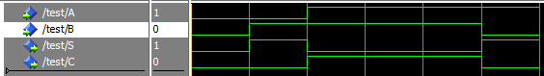
Πίνακας:

Α | Β | C | S
0 | 0 | 0 | 0
0 | 1 | 0 | 1
1 | 0 | 0 | 1
1 | 1 | 1 | 0

Ερώτημα 9

Κώδικας:

library ieee;
use ieee.std_logic_1164.all;

entity fa is port (
A, B, Cin : in bit;
S, Cout : out bit);
end fa;

ARCHITECTURE dataflow OF fa IS
BEGIN
S <= a xor b xor Cin;
Cout <= (a and b) or (cin and (a xor b));
END dataflow;

Wave

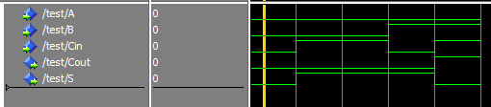

Πίνακας:

Α | Β | Cin | Cout | S
0 | 0 | 0 | 0 | 0
0 | 0 | 1 | 0 | 1
0 | 1 | 0 | 0 | 1
0 | 1 | 1 | 1 | 0
1 | 0 | 0 | 0 | 1
1 | 0 | 1 | 1 | 0
1 | 1 | 0 | 1 | 0
1 | 1 | 1 | 1 | 1

Ερώτημα 10

Κώδικας:

library ieee;
use ieee.std_logic_1164.all;

ENTITY adder4 IS PORT (
Cin : IN STD_LOGIC;
X, Y : IN STD_LOGIC_VECTOR(3 DOWNTO 0);
S : OUT STD_LOGIC_VECTOR(3 DOWNTO 0);
Cout : OUT STD_LOGIC);
END adder4;

Wave

Πίνακας:

Α | Β | Cin | Cout | S
0000 | 0000 | 0 | 0 | 0000
1111 | 1111 | 0 | 1 | 1110
1111 | 1111 | 1 | 1 | 1111

